***Image Quality Assesment***

Kadir Aktas

University of Tartu,

Tartu, Estonia

Simon Wu

University of Tartu,

Tartu, Estonia

Image quality characteristics of an image are subjective when there are not mathematical calculations included. Our aim is to assess image quality of an image by using mathematical calculations based on pixel values and patterns on the images. In this project, assessment is done between two images whereas one of them is the original image and the other one is the assessed image. The result consists referenced and non-referenced image quality assessments. Additionally, faces on the images are detected and number of faces are obtained.

# INTRODUCTION

Image quality assessment is a huge topic and there are many ways to assess quality of an image. A person can look at two images and can evaluate one as a better image. Obviously, an assessment without mathematical calculations and comparison is subjective. Thus, new calculations to assess image quality are often introduced by researches. Therefore, a certain number of calculations to obtain characteristics of an image are described.

However, there is not a single program that calculates several image quality characteristics and makes an assessment. In our project, we created a program which calculates several image quality characteristics of an image, based on certain calculations, to provide mathematical data about the quality of an image. These calculations are mentioned one by one in methodology section of this report.

# DESIGN

In the program, two images are taken as input and image quality characteristics of one of these images are calculated compared to the other image.

The program has a GUI (Graphical User Interface) (Picture 1) which has three main parts, respectively.

First part is “Load Image” section. There are five different buttons to interact with the user in this section. User can click to “Assessed Image” and “Original Image” buttons to select an image from the disk, and a second image to make the comparison with. After selecting the images, “Detect Face”, “Assess it!” and “Histogram” buttons are used to examine the images. By clicking to “Detect Face” button, program draws squares around the faces in the pictures. “Histogram” button displays the histograms of each image. Lastly, “Assess it!” button makes the calculations of quality metrics for the “Assessed Image”.

Second part is “Preview” section. In this section, the selected images are shown. Also, histograms of these images are shown here respectively, if the “Original Histogram” or “Assessed Histogram” button is clicked. In the picture 1, a histogram drawn by the program is shown for example.

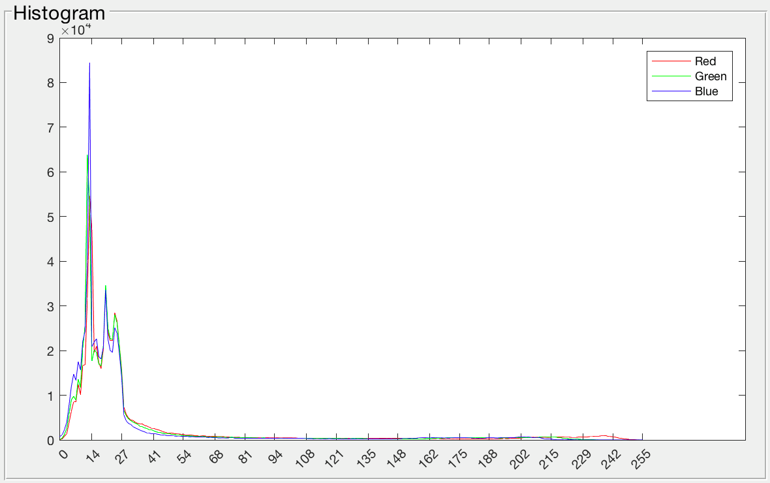

Picture 1: Example Histogram

Last part is the “Quality Metrics” section. In this section, 21 different characteristics of “Assessed Image” is displayed if the “Assess it!” button is clicked. Also a short assessment about “Assessed Image” is made.

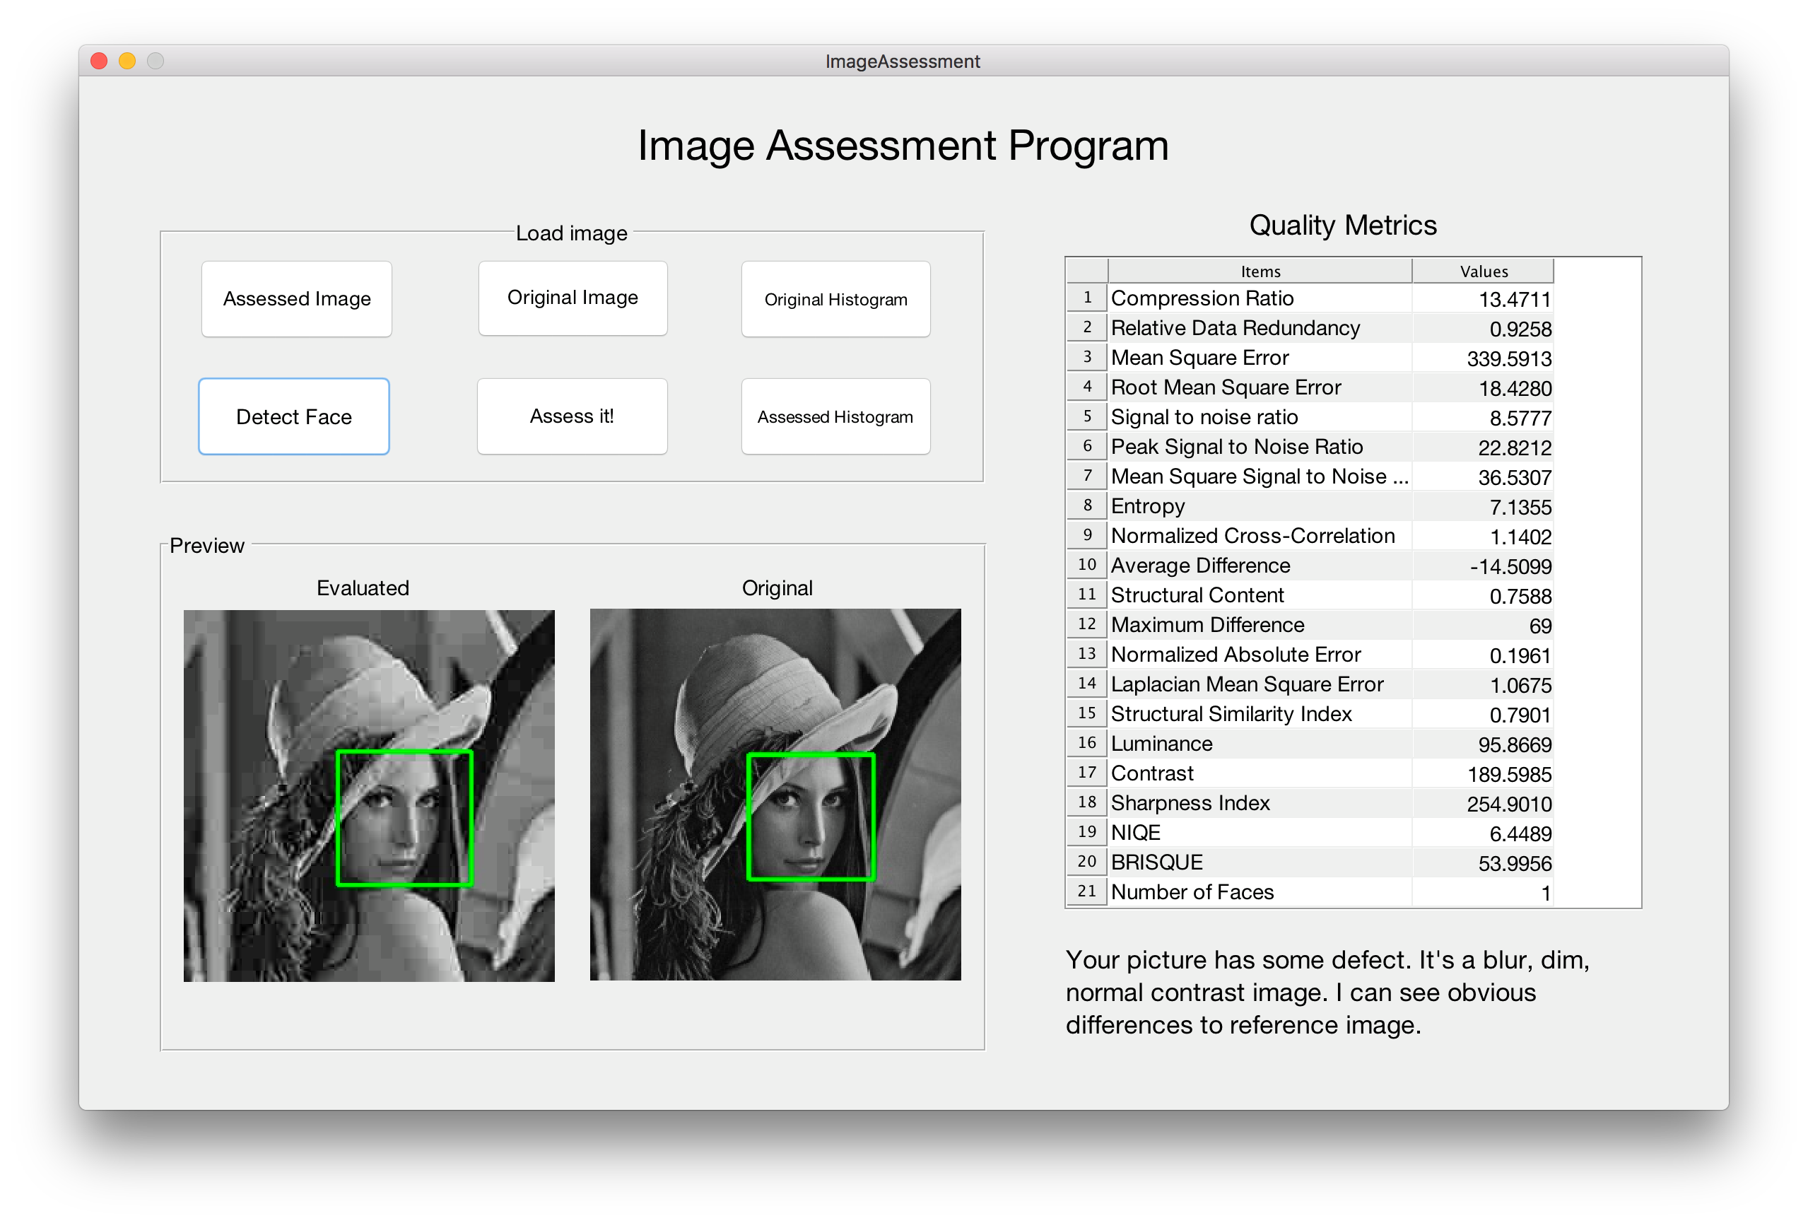

Picture 2: Graphical User Interface of the Program

# METHODOLOGY

In the program, 21 different calculations are made for “Assessed Image”. While 18 of these calculations are referenced to the “Original Image”, 2 of them are non-referenced. Additionally, faces in the images are detected and number of faces in the “Assessed Image” is calculated. In the following, all these functions are briefly explained.

Compression Ratio: Compares the sizes of images to understand if the assessed image is compressed well. If the images are same, output should be 1. The bigger value for compression ratio means image is compressed more.

Relative Data Redundancy: This function is related to compression ratio. It gives us mathematical value for data redundancy. If the images are same, this value should be 0. The bigger value means there is more data redundancy.

Mean Square Error: Calculates the differences between the images. The larger the value is the more different the images are.

Root Mean Square Error: Another way to calculate the differences between the images. The larger the value is the more different the images are.

Signal to Noise Ratio: It is power of signal divided by power of noise. So it compares desired value to noised value. That means if SNR is higher, there are less noise, quality of image is better.

Peak Signal to Noise Ratio: In the calculation, square of max value of a pixel divided by MSE is examined. When comparing the compression codecs, this value is an approximation for human perception of reconstruction quality. If it is below 25, it means bad quality. If it is between 25 and 35, it means human can see the differences. Lastly, if it is bigger than 35, it means human can hardly distinguish differences between two images.

Mean Square SNR: It has a different calculation but trend is similar to SNR. The higher value means better quality.

Entropy: It shows the information for each pixel. More entropy means there is more information per pixel in the image.

Normalized Cross-Correlation: It shows the similarity between two images. If the images are same, the value is 1. It differs from 1 more and more if the images become more different.

Average Difference: It is average of the total error. Closer to 0 means they are similar. Being close to 0 is better quality for noisy images.

Structural Content: Calculates structural similarity with a different calculation. The larger value means the image has poor quality. If they are same the value is 1.

Maximum Difference: It shows the max error. It compares all the pixels and picks the max error value. In some cases, this information may be important but in some cases it may be less important. But generally, the higher is maximum difference, the quality is lower.

Normalized Absolute Error: Another error calculation function but in this case we take the absolute value of the error. And divide it by sum of original image value. For quality, it means the higher this value, the quality is lower.

Laplacian Mean Square Error: This rather a complicated calculation. It is based on algebra and edges in the image. The larger value means the image quality is poor quality.

Structural Similarity Index: It shows the similarity between two images. Calculation is based on luminance, contrast and structure. If the images are same the value is 1.

Luminance: Mean value of the luminance of pixels. The bigger value means the image is brighter.

Contrast: It is the difference between the values of pixels. If the contrast is higher, pixel values are distributed more uniformly.

Sharpness Index: If the image is sharper, you can see the colors separately better. So if the image is sharper, it means image is less blurry.

Naturalness Image Quality Evaluator(NIQE): This is a non-referenced quality factor. Compares the image to a model. This model is computed with images of natural scenes. Closer to 0 means better quality.

Blind/Referenceless Image Spatial Quality Evaluator(BRISQUE): This is a non-referenced quality factor. Compares the image to a model. This model is computed with images of natural scenes with similar distortions. Closer to 0 means better quality.

Face detection: Faces in each image is detected and number of faces are counted by using haar cascade face detection method.

Additionally, a short assessment is made according to the calculations. While making this assessment, results of NIQE, sharpness, luminance and peak signal to noise ratio values are used.

# RESULTS

Program can be used for different use cases. For some cases, the results of some functions can be more important than the other results. So, the assessment changes according to use cases. In some cases, it is necessary to do evaluation with one more image to understand the result.

Meaning of the results for each function is explained in the methodology part of this report. According to use cases, the result of a function can be examined and an assessment about the image can be made.

# CONCLUSION

There are many image quality characteristics to calculate while making an assessment about an image. But there is not a tool which collects these calculations in a single user friendly interface. In this project, we offer a tool to evaluate several different characteristics in the same interface.

Using this tool, 21 different quality characteristics can be evaluated. According to the use case, an objective assessment about the image can be made since the results are mathematical values.

In the future work, functions in the program can be increased by adding new functions. Face detection algorithm can be improved. Assessment done in the program can be extended.

##### REFERENCES

1. G. Eason, B. Noble, and I.N. Sneddon, “On certain integrals of Lipschitz-Hankel type involving products of Bessel functions,” Phil. Trans. Roy. Soc. London, vol. A247, pp. 529-551, April 1955. (*references*)
2. J. Clerk Maxwell, A Treatise on Electricity and Magnetism, 3rd ed., vol. 2. Oxford: Clarendon, 1892, pp.68-73.
3. I.S. Jacobs and C.P. Bean, “Fine particles, thin films and exchange anisotropy,” in Magnetism, vol. III, G.T. Rado and H. Suhl, Eds. New York: Academic, 1963, pp. 271-350.
4. K. Elissa, “Title of paper if known,” unpublished.
5. R. Nicole, “Title of paper with only first word capitalized,” J. Name Stand. Abbrev., in press.
6. Y. Yorozu, M. Hirano, K. Oka, and Y. Tagawa, “Electron spectroscopy studies on magneto-optical media and plastic substrate interface,” IEEE Transl. J. Magn. Japan, vol. 2, pp. 740-741, August 1987 [Digests 9th Annual Conf. Magnetics Japan, p. 301, 1982].
7. M. Young, The Technical Writer’s Handbook. Mill Valley, CA: University Science, 1989.